`

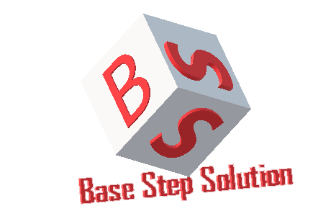

Meeting Minutes

Van Lang Admissions

# Revision Table

|  |  |  |  |
| --- | --- | --- | --- |
| Author | Date | Reason for changes | Version |
| Khoi Nguyen | 23/01/2017 | Initial Document | 1.0 |

Table of Contents

Revision Table 1

I. Purpose 3

II. Participant in meeting 3

III. Content of meeting 3

IV. To do task 4

|  |  |  |  |  |  |
| --- | --- | --- | --- | --- | --- |
| **Writer:** | Khởi Nguyễn | **Location:** | Floor 9, Etown 2 | | |
| **Date:** | 23/01/2017 | **Start:** | 13h | **Finish:** | 16h |

# Purpose

Discuss about functions of Capstone Project

Review technical , requirement

# participant in meeting

Mentor Vũ Thế Nam

Team Capston:

* Nguyễn Thái Hiền
* Nguyễn Hoàng Anh Tài
* Đoàn Anh Minh
* Trần Xuân Hải
* Nguyễn Anh Khởi

# Content of meeting

* How many types of view?
  + Top subpage
  + Hot View
  + List View
  + Detail View
* Tool resize images
* Review Data Diagram
  + Account: Do not need status, where to define account type?
  + Priority 🡪 Type, how many types? Restore pass? missing Email, expire date?
  + Banners depends on the categories? Are banners dependent on subpage? Banner links to news.
  + Banners/Pop-ups have status, images, links
  + News: có Create date (hide), Edit date (hide), Public date (show)
  + Students: have Email
  + QA: Có Email (required), Question (required), Status (required), Name (optional), Số điện thoại (optional)
* Review Physical View:
  + Balancer: Only use when the server has the same function
  + Mobile browser

# To do task

* Update documents

---- *** ----